COVER PAGE
Analysis of the 2017 Equifax Data Breach

Prepared By: Samuel Ochoche Peter

Course: Cybersecurity

Institution: 3MTT
Date: 2nd June, 2026
1. Executive Summary
This project analyzes the 2017 Equifax data breach, one of the largest cybersecurity breaches in history. Equifax, a major credit reporting agency, suffered a breach that exposed the personal information of about 147 million people. The breach occurred because attackers exploited an unpatched Apache Struts vulnerability known as CVE-2017-5638. The incident showed the importance of patch management, vulnerability scanning, network monitoring, encryption, and incident response.
2. Scope of the Project
The scope of this project is to analyze:
- The target organization affected by the breach
- The attack vector used by the attackers
- The vulnerability exploited
- The timeline of the breach
- The assets affected
- The impact on customers and the organization
- The incident response process
- Security controls that could have prevented or reduced the impact
3. Target Organization
Organization: Equifax Inc.
Industry: Credit Reporting / Financial Services
Breach Year: 2017
Affected Users: Approximately 147 million people
Type of Breach: Web application compromise and data exfiltration
Equifax stores highly sensitive consumer data such as names, Social Security numbers, birth dates, addresses, and driver’s license numbers, making it a high-value target for cybercriminals and nation-state attackers. The FTC states that Equifax announced in September 2017 that the breach exposed the personal information of 147 million people. (Federal Trade Commission)
4. Assets, Threats, and Vulnerabilities

Category | Details
Assets | Consumer personal information, credit records, web applications, databases, internal systems
Threats | Data theft, identity theft, web application exploitation, unauthorized access, regulatory penalties
Vulnerabilities | Unpatched Apache Struts vulnerability, weak vulnerability management, poor detection capability, certificate monitoring failure, inadequate segmentation

5. Attack Vector and Initial Compromise
The attackers exploited a known vulnerability in Apache Struts, identified as CVE-2017-5638. Apache had released a patch in March 2017, but Equifax failed to apply the patch to the affected web application. The U.S. House Oversight report described the breach as preventable and noted that the vulnerability was publicly disclosed on March 7, 2017, with DHS alerting Equifax the next day. (House Oversight Committee)
Once the attackers gained access, they were able to move through Equifax systems and access sensitive consumer information. The breach went undetected for weeks, partly because encrypted traffic inspection was not working properly due to an expired digital certificate, according to GAO reporting and related analysis. (GAO)

6. Timeline of the Breach
Date / Period | Event
March 7, 2017 | Apache Struts vulnerability publicly disclosed and patch released
March 8, 2017 | DHS alerted Equifax about the vulnerability
May 2017 | Attackers exploited the unpatched Apache Struts vulnerability
May–July 2017 | Attackers accessed and exfiltrated sensitive data
July 2017 | Equifax detected suspicious activity
September 2017 | Equifax publicly disclosed the breach
2019 | Equifax agreed to a global settlement with FTC, CFPB, and states

7. Impact of the Breach
Data Loss
The breach exposed highly sensitive personal information including:
- Names
- Social Security numbers
- Birth dates
- Addresses
- Driver’s license numbers
This type of data is extremely dangerous because it can be used for identity theft and financial fraud.
Financial Impact
Equifax agreed to a global settlement of at least $575 million, potentially up to $700 million, with the FTC, CFPB, and U.S. states and territories. (Federal Trade Commission)

Regulatory and Legal Impact
The breach led to investigations, lawsuits, regulatory penalties, and public criticism of Equifax’s cybersecurity practices. The CFPB also announced the settlement with Equifax, stating that it involved up to $700 million in monetary relief. (Consumer Financial Protection Bureau)
Reputation Impact
The breach damaged public trust because Equifax’s business depends on protecting consumer credit information. The incident became a major example of how failure to patch known vulnerabilities can create serious consequences.
8. Incident Response Review
Equifax eventually detected the breach and shut down the exploit, but the response was criticized because:
- The vulnerability was known before the attack
- The patch was available but not applied properly
- Detection was delayed
- Public disclosure happened weeks after discovery
- The breach affected a very large number of people
The incident showed that incident response is not only about reacting after an attack, but also about preparation, monitoring, communication, and rapid remediation.

9. Security Controls That Could Have Prevented or Reduced the Breach
Security Control | How It Would Help
Patch Management | Apply Apache Struts patch quickly after disclosure
Vulnerability Scanning | Detect outdated or vulnerable software
Asset Inventory | Identify all systems running Apache Struts
Web Application Firewall | Block exploitation attempts
Network Segmentation | Limit attacker movement after initial access
SIEM Monitoring | Detect suspicious activity earlier
Certificate Monitoring | Prevent failure of encrypted traffic inspection
Data Encryption | Reduce exposure if data is stolen
Least Privilege | Limit access to sensitive databases
Incident Response Plan | Improve detection, containment, communication, and recovery

10. Evidence and Screenshots
Overview
The screenshots included in this section serve as supporting evidence for the research, analysis, and documentation conducted during this cybersecurity case study. The screenshots demonstrate the research process, vulnerability analysis, timeline development, risk assessment activities, and security control recommendations related to the Equifax Data Breach.
Screenshot 1: FTC Equifax Data Breach Settlement
File Name: equifax_ftc_settlement_page.png
Description
This screenshot shows the Federal Trade Commission (FTC) official page regarding the Equifax Data Breach Settlement. The page provides information about the breach, the number of affected individuals, consumer compensation, and regulatory actions taken against Equifax.
Purpose
The screenshot serves as evidence that the breach resulted in significant legal and financial consequences and demonstrates the regulatory response to the incident.
Key Findings
- Approximately 147 million individuals were affected.
- Equifax faced substantial financial penalties.
- The breach triggered multiple investigations and lawsuits.
- The incident became one of the largest consumer data breaches in history.
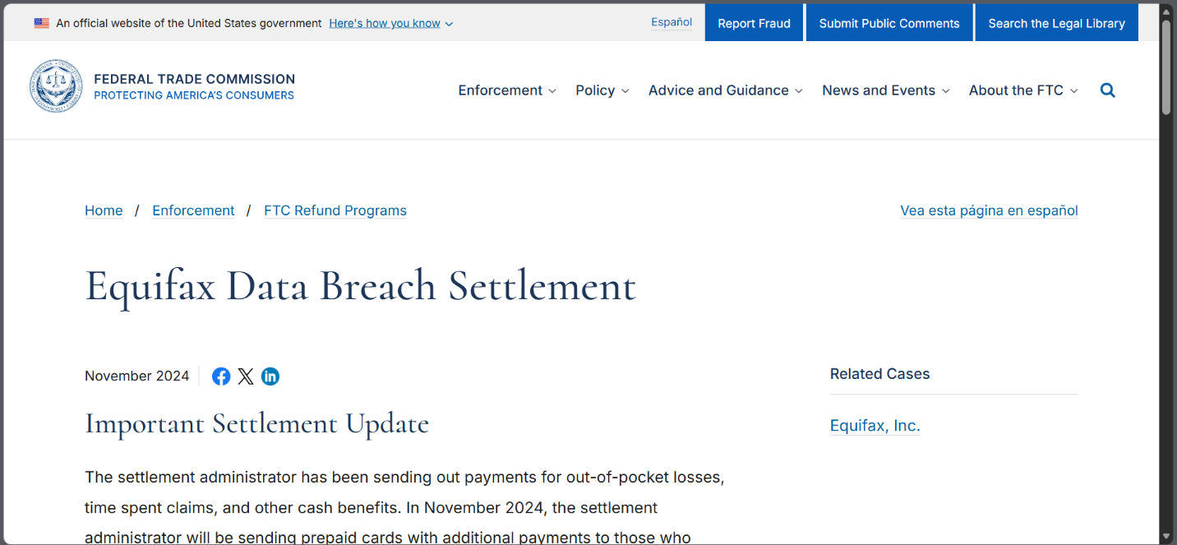

Screenshot 2: Apache Struts Vulnerability Research
File Name: apache_struts_vulnerability_research.png
Description
This screenshot displays information regarding the Apache Struts vulnerability (CVE-2017-5638), which was the primary attack vector exploited during the Equifax breach.
Purpose
The screenshot provides evidence of the technical vulnerability that allowed attackers to gain unauthorized access to Equifax systems.
Key Findings
- Vulnerability Identifier: CVE-2017-5638
- Affected Technology: Apache Struts Framework
- Severity: Critical
- Patch Available Prior to Attack
- Exploited Due to Failure to Apply Security Updates
Security Lesson
Organizations must maintain effective patch management processes to prevent exploitation of known vulnerabilities.
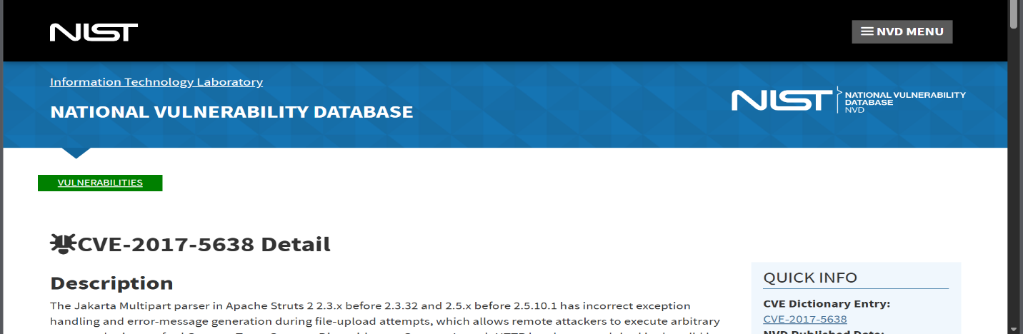
Screenshot 3: NIST / CISA Security Guidance
File Name: nist_or_cisa_patch_management_reference.png
Description
This screenshot shows cybersecurity guidance from either the National Institute of Standards and Technology (NIST) or the Cybersecurity and Infrastructure Security Agency (CISA).
Purpose
The screenshot demonstrates industry best practices for vulnerability management, risk assessment, patch management, and cybersecurity governance.Key Findings
- Importance of continuous monitoring.
- Need for timely patch deployment.
- Security frameworks improve organizational resilience.
- Risk management is essential for protecting critical assets.
Security Lesson
Following recognized security frameworks significantly reduces organizational exposure to cyber threats.
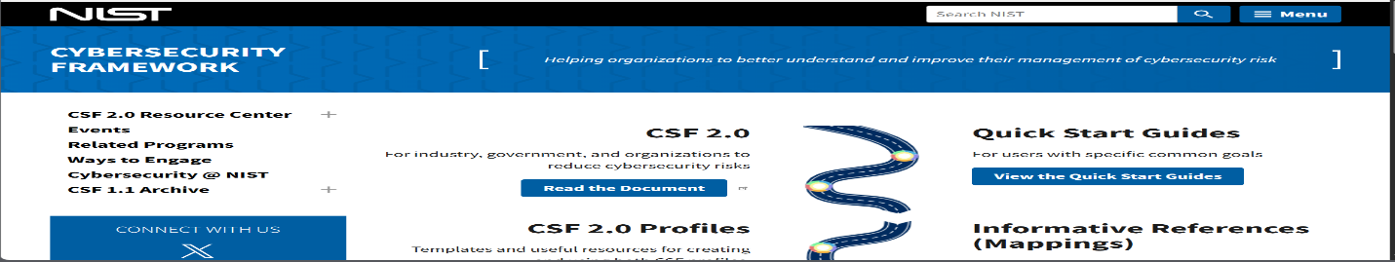
Screenshot 4: Cybersecurity Timeline Design
File Name: timeline_design.png
Description
This screenshot shows the development of the historical cybersecurity timeline created using Draw.io or another visualization tool.
Purpose
The screenshot demonstrates the research and visualization process used to organize cybersecurity milestones from 1971 to the present.
Timeline Milestones Included
- Creeper Program (1971)
- Reaper (1972)
- Morris Worm (1988)
- ILOVEYOU Virus (2000)
- Stuxnet (2010)
- WannaCry (2017)
- SolarWinds (2020)
- Zero Trust Architecture (2020)
- AI-Driven Security (2023-Present)
Security Lesson
Cybersecurity continuously evolves in response to emerging threats and technological advancements.
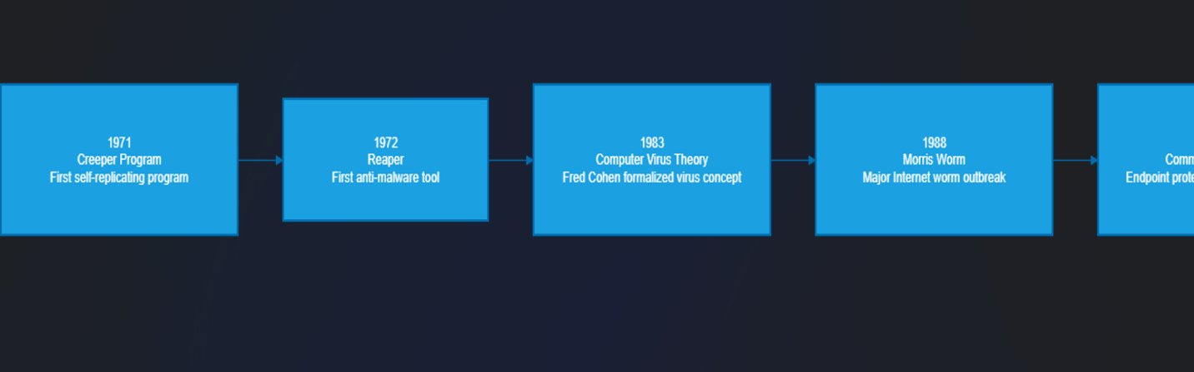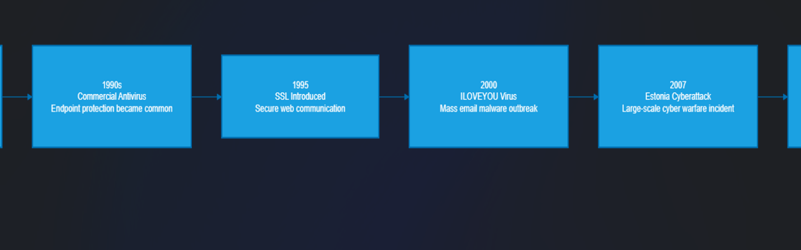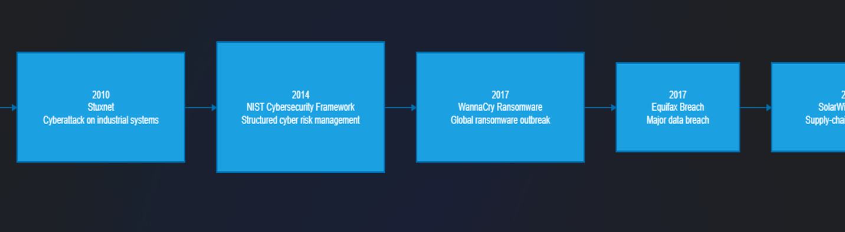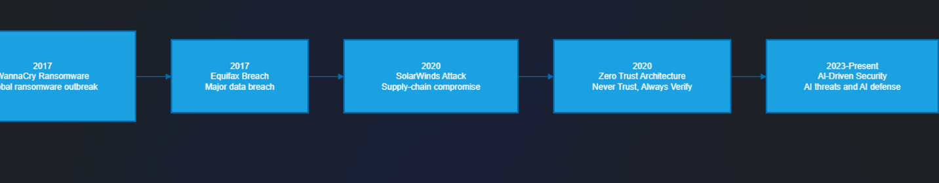
Screenshot 5: Risk Analysis Table
File Name: risk_analysis_table.png
Description
This screenshot presents the risk analysis conducted as part of the Equifax breach case study.
Purpose
The risk analysis identifies critical assets, threats, and vulnerabilities associated with the incident.
Example Risk Assessment
Asset | Threat | Vulnerability
Customer Data | Data Theft | Unpatched Software
Web Application | Unauthorized Access | Apache Struts Vulnerability
Database Systems | Data Exfiltration | Weak Monitoring Controls

Security Lesson
Risk assessments help organizations identify weaknesses before attackers can exploit them.
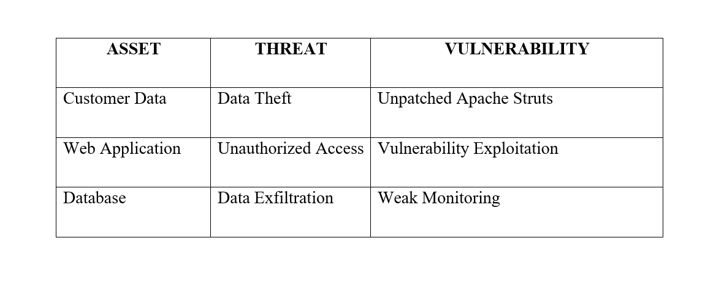

Screenshot 6: Security Controls and Mitigation Table
File Name: security_controls_table.png
Description
This screenshot shows the recommended security controls that could have prevented or reduced the impact of the Equifax breach.
Purpose
The screenshot demonstrates the relationship between identified vulnerabilities and appropriate security controls.
Recommended Controls
Security Control | Purpose
Patch Management | Address known vulnerabilities
Vulnerability Scanning | Detect security weaknesses
SIEM Monitoring | Identify suspicious activity
Web Application Firewall | Block malicious traffic
Multi-Factor Authentication | Strengthen access control
Network Segmentation | Limit attacker movement
Incident Response Plan | Improve breach response

Security lesson
Layered security controls provide stronger protection than relying on a single security mechanism.
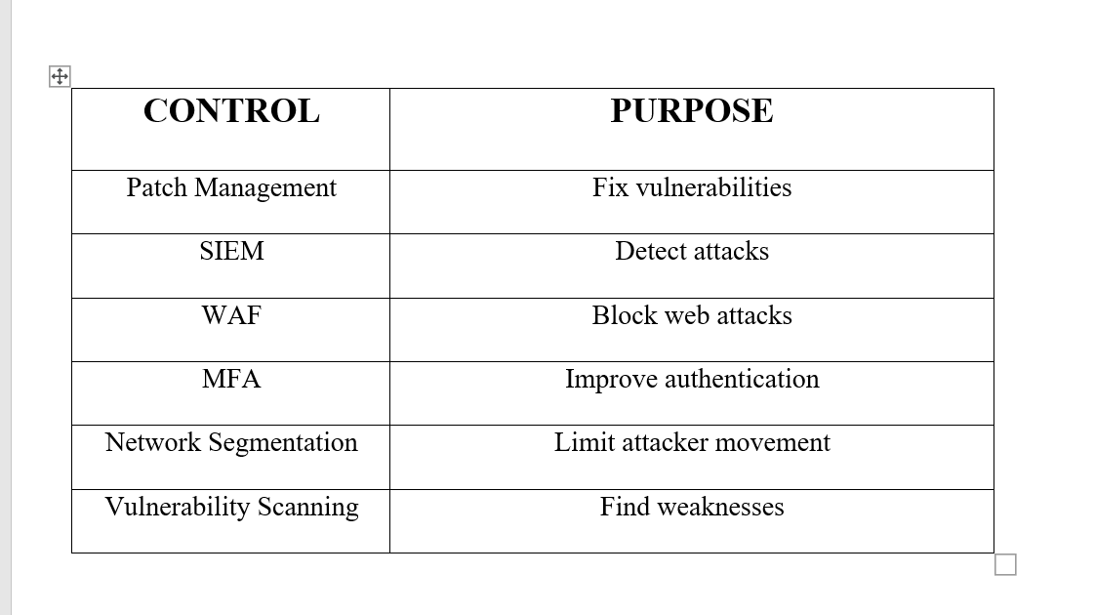

Summary of Evidence
The screenshots included in this report support the technical analysis of the Equifax Data Breach and demonstrate the research process used to identify attack vectors, vulnerabilities, business impacts, and recommended security controls. Together, they provide evidence of the methodology used in this cybersecurity case study and reinforce the importance of proactive security management, vulnerability remediation, and continuous monitoring.
11. Methodology and Tools Used
Tool / Method | Purpose
Web Research | Gather reliable information about the breach
Timeline Analysis | Understand breach progression
Risk Assessment | Analyze threats, vulnerabilities, and impact
Control Mapping | Recommend preventive controls
Draw.io / Word | Create timeline and report documentation

12. Lessons Learned
The Equifax breach teaches that cybersecurity failures often happen because of poor basic security practices. The attack did not require a completely unknown vulnerability; it exploited a known issue for which a patch already existed. This shows the importance of patch management, asset inventory, monitoring, and accountability.
The breach also shows that organizations handling sensitive data must treat cybersecurity as a business-critical function, not only an IT responsibility.
13. Conclusion
The 2017 Equifax data breach was a major cybersecurity failure caused mainly by poor vulnerability management and delayed detection. Attackers exploited an unpatched Apache Struts vulnerability and gained access to highly sensitive consumer data. The breach affected millions of people and resulted in major financial, legal, and reputational consequences.
To prevent similar attacks, organizations must implement strong vulnerability management, continuous monitoring, encryption, network segmentation, and effective incident response planning. The Equifax breach remains an important lesson in the need for proactive cybersecurity governance and disciplined security operations.
14. References
- Federal Trade Commission. Equifax Data Breach Settlement. (Federal Trade Commission)
- U.S. House Oversight Committee. The Equifax Data Breach Report. (House Oversight Committee)
- Government Accountability Office. Actions Taken by Equifax and Federal Agencies in Response to the 2017 Breach. (GAO)
- Consumer Financial Protection Bureau. CFPB, FTC and States Announce Settlement with Equifax. (Consumer Financial Protection Bureau)
- Federal Trade Commission. Equifax Inc. Case Summary. (Federal Trade Commission)

